* -: I got a little example project set up here and you can find it attached to this video.

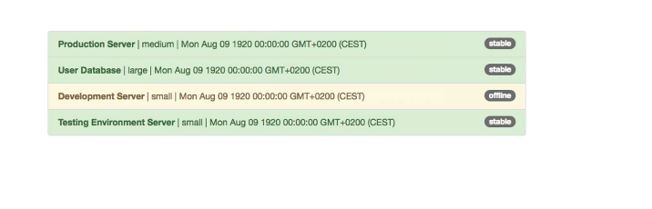

* 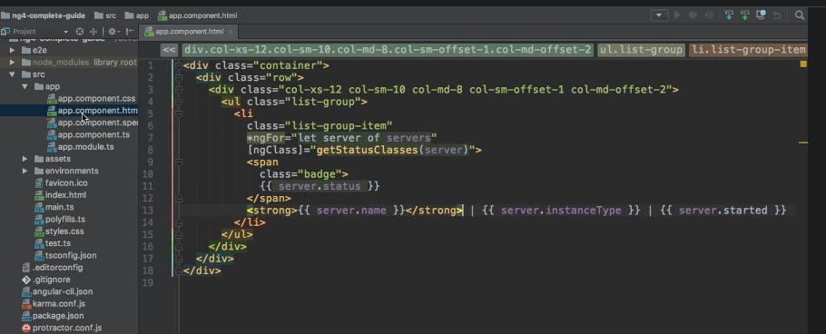
* Now, the code responsible for what you saw here on the screen is basically this app component template where I output a list of servers and the servers are stored here in my app component TypeScript file.

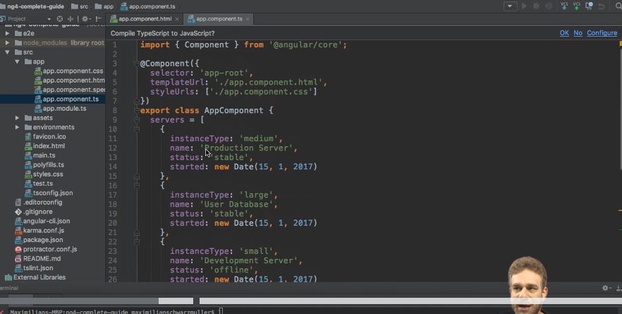

* I got the service array, which simply holds a couple of JavaScript objects each representing a server.
* And then at the bottom here I get a little helper class which simply retrieves the right CSS classes which should be attached to that list group item depending on the state of the server, if it's stable or offline.
* So this is the project we're starting with.
* It looks alright, but it get a couple of things we could fix here.
* Now, for example, we got a server name, which looks all right to me, but then we get this instance type here medium, large, small, and we get this date.
* Now you could, for example, put this instance type to be all upper case and the date.
* I'd like to change something about the date too but let's start with the instance type, medium, large, small here, to see how to use pipes.
* And you will see it's actually pretty simple.
* ***To change it, we have to go to the template to the HTML file, because remember a pipe is only responsible for transforming the output.***
* So the right place to use it logically is the template.
* Now here I want to change this server instance type thing here.

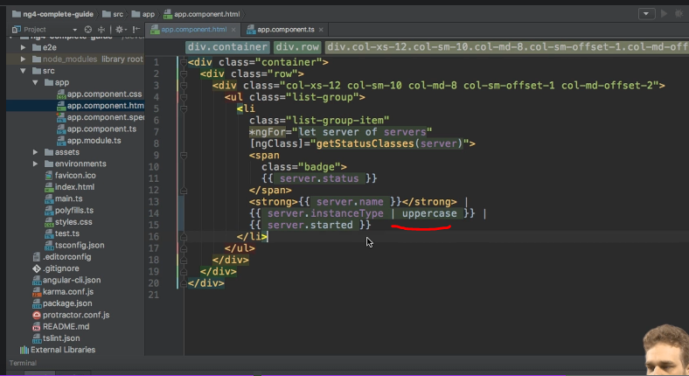

* I'll just bring it into a new line here.
* And the same for servers started just to make it a bit easier to read.
* And now I would like this server instance type to be uppercase.
* Now that's easy to achieve.
* We just add the pipe symbol, hence to name pipes and then the name of the pipe.
* And as mentioned before, there are a couple of built-in pipes and you can also build pipes on your own.
* We'll have a look at this in one of the next lectures.
* Now a good built-in pipe for making this all upper case.
* Of course, it's the upper case pipe you saw on the slide before.

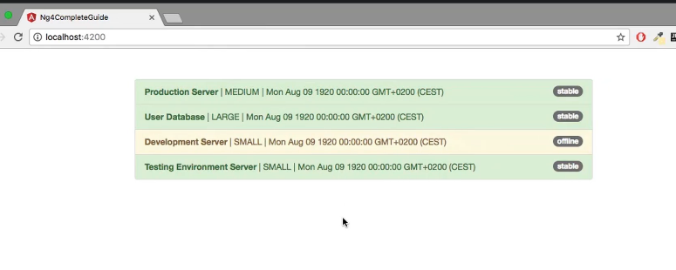

* With that added, you now see if you saved this and go back to your webpage that all the instance types here have been converted to be upper case.
* So without changing anything else, without, and that's important, changing the property itself here the statuses, excuse me, the instance types are still lowercase.
* Without changing anything here, we change the way users can view it simply by adding a pipe here.
* That looks pretty good to me.
* Now let's move on to the date.
* And for this we got another pipe we could use.

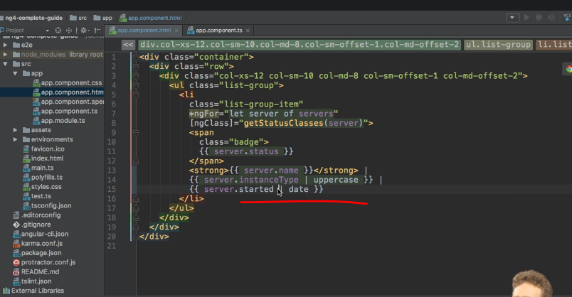

* So if we have a look at the HTML code here these servers started output here is responsible for rendering the date.
* Well, if we add the pipe symbol here too, we could add the date pipe, and now we're built in type.
* And I will come back to where you find those built in pipes, in a second.

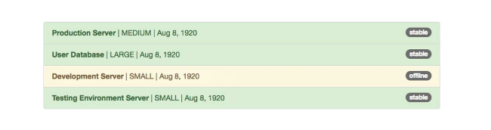

* Now with this added, let's save this and now you see out of the box, this looks much nicer.
* But it might not be the way you want it to look.
* So let's learn more about how to configure pipes in the next video.